
SRM Institute of Science and Technology
Register Number
College of Engineering and Technology
School of Computing
SRM Nagar, Kattankulathur – 603203, Chengalpattu District, Tamilnadu
Academic Year: 2024 - 25 EVEN
B. Tech-School of Computing
Test: FT3 Date: 08.04.2025
Course Code & Title: 21CSE356T – Natural Language Processing Duration: 2 periods
Sem: VI Sem Max. Marks: 50
Batch I SET: C
Course Articulation Matrix:
S.No. | Course Outcome | PO1 | PO2 | PO3 | PO4 | PO5 | PO6 | PO7 | PO8 | PO9 | PO10 | PO11 | PO12 | PSO1 | PSO2 | PSO3
1 | CO1 | 3 | 3 | 2 |  |  |  |  |  |  |  |  |  | 2
2 | CO2 | 3 | 3 | 2 |  |  |  |  |  |  |  |  |  | 2
3 | CO3 | 3 | 3 | 2 |  |  |  |  |  |  |  |  |  | 2
4 | CO4 | 3 |  |  | 3 | 3 |  |  |  |  |  |  |  | 2
5 | CO5 |  |  | 2 | 3 | 3

Part – A
Answer all questions (10 x 1=10 marks)
Q. No | Question | Answers | Marks | BL | CO | PO | PI Code
 | 1. What does lexical semantics primarily study?  A) Sentence structure  B) Word meanings and relationships  C) Speech recognition  D) Syntax rules |  | 1 | 2 | CO3 | 1 | 2.6.1
 | What is the phenomenon where a single word has multiple meanings?  A) Synonymy  B) Polysemy  C) Hyponymy  D) Antonymy |  | 1 | 2 | CO3 | 1 | 2.6.2
 | Which of the following is NOT a type of word sense relation?  A) Homonymy  B) Synonymy  C) Morphology  D) Hyponymy |  | 1 | 2 | CO3 | 1 | 2.6.1
 | What is the main goal of Word Sense Disambiguation (WSD)?  A) To find new words  B) To determine the correct meaning of a word in context  C) To analyze grammatical structures  D) To create new synonyms |  | 1 | 2 | CO3 | 1 | 2.6.1
 | Which of the following is an example of homonymy?  A) "Bank" meaning both a financial institution and a riverbank  B) "Bright" meaning both intelligent and well-lit  C) "Car" and "Automobile" meaning the same thing  D) "Happy" and "Sad" being opposite meanings |  | 1 | 2 | CO3 | 1 | 2.6.2
 | What is the main goal of Word Embeddings?  A) To translate text into another language  B) To represent words as dense vectors in a continuous space  C) To segment text into sentences  D) To count word frequencies in a document |  | 1 | 2 | CO4 | 3 | 2.6.1
 | What is the primary limitation of Recurrent Neural Networks (RNNs)?  A) They require a large dataset to train  B) They cannot process sequential data  C) They suffer from vanishing gradient problem  D) They are faster than feedforward networks |  | 1 | 2 | CO4 | 1 | 2.6.1
 | How does an LSTM network solve the vanishing gradient problem?  A) By introducing a new activation function  B) By using a memory cell and gating mechanism  C) By increasing the number of layers  D) By discarding previous time steps entirely |  | 1 | 2 | CO4 | 1 | 2.6.1
 | What is the key advantage of the Transformer model over RNNs?  A) It processes sequences in parallel rather than sequentially  B) It has fewer parameters than RNNs  C) It does not require large datasets for training  D) It does not use attention mechanisms |  | 1 | 2 | CO4 | 1 | 2.6.1
 | In an Attention Model, what is the purpose of the attention weights?  A) To discard irrelevant words in a sequence  B) To adjust the importance of different words in context  C) To increase computational efficiency  D) To limit the number of training parameters |  | 1 | 2 | CO4 | 1 | 3.6.2

SRM Institute of Technology
Register Number
College of Engineering and Technology
School of Computing
SRM Nagar, Kattankulathur – 603203, Chengalpattu District, Tamil Nadu
Academic Year: 2024 - 25 EVEN
B. Tech-School of Computing
Test: FT3 Date: 08.04.2025
Course Code & Title: 21CSE356T – Natural Language Processing Duration: 2 periods
Sem: VI Sem Max. Marks: 50
Batch I SET: C
Course Articulation Matrix:
S.No. | Course Outcome | PO1 | PO2 | PO3 | PO4 | PO5 | PO6 | PO7 | PO8 | PO9 | PO10 | PO11 | PO12 | PSO1 | PSO2 | PSO3
1 | CO1 | 3 | 3 | 2 |  |  |  |  |  |  |  |  |  | 2
2 | CO2 | 3 | 3 | 2 |  |  |  |  |  |  |  |  |  | 2
3 | CO3 | 3 | 3 | 2 |  |  |  |  |  |  |  |  |  | 2
4 | CO4 | 3 |  |  | 3 | 3 |  |  |  |  |  |  |  | 2
5 | CO5 |  |  | 2 | 3 | 3

Part –B
Answer ALL questions (4 x 5=20 marks)
Q. No | Question | Marks | BL | CO | PO | PI Code
11.a. | A chatbot on an e-commerce platform struggles with user queries. For example, when a user says, "I need a bat for my son," it suggests both cricket bats and flying bats. Similarly, when asked, "My order is delayed. Can you check its status?", the chatbot fails to link "it" to "order".  Question: Identify the NLP challenges in these cases and explain how Word Sense Disambiguation (WSD) and Coreference Resolution can improve chatbot performance. Discuss their applications, advantages, and limitations.  Solution:  NLP Challenges Faced by the Chatbot:  - Lexical Ambiguity: The chatbot fails to differentiate between multiple meanings of the word bat (sports vs. animal). This is a common issue in natural language understanding.  - Reference Ambiguity: The chatbot does not correctly identify the referent of pronouns like "it" in user queries, leading to confusion in responses.  Role of WSD and Coreference Resolution:  - Word Sense Disambiguation (WSD): WSD determines the correct meaning of a word based on context. It relies on knowledge-based (WordNet), supervised (Naïve Bayes, SVM), and deep learning (BERT, ELMo) approaches to improve chatbot accuracy.  - Coreference Resolution: This technique identifies and links words referring to the same entity, such as resolving "it" to "order". Models like Stanford NLP, SpaCy, and Hugging Face Transformers use contextual learning to improve reference understanding.  Application in Chatbots:  - WSD ensures that "bat" is understood as a sports bat if the query context includes "son".  Coreference resolution enables the chatbot to resolve "it" as "order" in a conversation  Advantages:  - Improves chatbot accuracy and user experience.  - Reduces irrelevant or incorrect responses.  - Enhances contextual understanding in dialogues.  Limitations:  - Requires large training datasets for accurate prediction.  - Contextual ambiguity in short queries can still lead to errors.  - Computational complexity increases with deep learning models.  By integrating WSD and coreference resolution, chatbots can better interpret user intent and respond more effectively in customer interactions. | 5 | 4 | CO3 | 1 | 3.6.2
 | (OR)
11.b. | A company uses AI to generate product descriptions for an e-commerce website. However, the generated text lacks coherence, as seen in the following example:  "The phone has a 48MP camera. Additionally, a laptop has a sleek design with 16GB RAM."  Question: Explain the issue in the AI-generated text and describe how Word Embeddings and Text Coherence models can improve content quality. Discuss their applications, advantages, and limitations.  Solution:  Issue in AI-Generated Text:  - The text lacks coherence because it randomly shifts from discussing a phone to a laptop without a clear transition.  - This affects readability and user engagement in e-commerce content.  Role of Word Embeddings & Text Coherence Models:  - Word Embeddings (Word2Vec, GloVe, FastText): These models map words into dense vector spaces where similar words have closer representations.  - Text Coherence Models:  - Lexical Cohesion: Ensures words in a passage are meaningfully related.  - Entity-Based Models: Track mentions of the same entity across sentences.  - Transformer-Based Models (BERT, GPT): Use context to maintain logical flow in text generation.  Application in AI-Generated Content:  - Word embeddings can help the AI recognize that phone and laptop belong to different categories, preventing random topic shifts.  - Coherence models ensure smooth transitions between sentences, maintaining logical flow.  Advantages:  - Improves content readability and user engagement.  - Helps in automated text summarization and chatbot responses.  - Reduces ambiguity in generated text.  Limitations:  - Requires large, high-quality datasets for effective training.  - May struggle with long-range dependencies in text. | 5 | 4 | CO3 | 1 | 3.6.2
12.a. | Explain the differences between Discourse Segmentation and Discourse Structure in NLP.  Solution: | 5 | 3 | CO3 | 3 | 3.6.1
  Feature | Discourse Segmentation | Discourse Structure
  Definition | Dividing text into meaningful units (sentences, paragraphs). | Organizing relationships between different text segments.
  Purpose | Helps in identifying where one idea ends and another begins. | Ensures logical flow and connectivity in text.
  Techniques Used | Rule-based methods, ML models, deep learning (e.g., BERT). | Rhetorical Structure Theory (RST), graph-based models.
  Application Areas | Text summarization, speech processing, dialogue systems. | Machine translation, automated reasoning, document structuring.
  Challenges | Identifying soft boundaries, dealing with implicit segmentation. | Handling complex discourse relations, multi-layered dependencies.
 | (OR)
12.b. | Define Pronominal Anaphora Resolution and Coreference Resolution. Explain their significance in NLP with one example each.  Solution:  - Pronominal Anaphora Resolution: Identifies the noun a pronoun refers to within a sentence or passage.  - Example: "John bought a book. He is reading it." (He → John, It → book).  - Coreference Resolution: Identifies all expressions that refer to the same entity within a text.  - Example: "The Prime Minister arrived. The leader of the country gave a speech." (Prime Minister = leader of the country).  - Significance in NLP:  - Improves chatbot interactions by maintaining context.  - Enhances machine translation by preserving entity consistency.  - Used in text summarization to avoid redundancy. | 5 | 4 | CO3 | 3 | 3.6.2
13.a. | Observe the given sentence and explain how Word Sense Disambiguation (WSD) can help in correctly interpreting the word "bank". Additionally, discuss how Reference Resolution is useful in resolving ambiguous references in NLP systems.  Sentence: “An image of a bank by the river and a financial bank building side by side”  Solution:  Word Sense Disambiguation (WSD) for "Bank"  - The word "bank" has multiple meanings:  - Financial Institution (e.g., savings bank).  - Riverbank (e.g., the land beside a river).  - WSD helps in choosing the correct meaning based on context using techniques like:  - Knowledge-based methods (WordNet, lexical databases).  - Machine Learning models (Naïve Bayes, SVMs).  - Deep Learning models (BERT, Transformers).  - Example in NLP:  - "He deposited money in the bank." → Financial bank.  - "She sat by the bank of the river." → Riverbank.  Reference Resolution in NLP  - Helps resolve pronouns and ambiguous entities to maintain context in conversations.  - Example:  - "John went to the bank. It was closed."  - Without reference resolution: "It" is unclear (bank could mean riverbank or financial bank).  - With reference resolution: NLP identifies that "it" refers to financial bank based on context.  Applications of WSD & Reference Resolution  - Chatbots & Virtual Assistants → Ensures correct responses based on user intent.  - Machine Translation → Prevents incorrect translations of ambiguous words.  - Information Retrieval → Improves search engines by understanding word meanings.  Limitations  - Requires large labeled datasets for deep learning models.  - Errors may occur in short or unclear contexts. | 5 | 4 | CO4 | 1 | 3.6.4
 | (OR)
13.b. | Explain the concept of Fine-Tuning in NLP. How does fine-tuning improve performance for downstream tasks such as text classification and text generation?  Solution:  Fine-Tuning in NLP  - Fine-tuning is the process of adapting a pre-trained language model (like BERT, GPT) to a specific task by training it on domain-specific data.  - Instead of training from scratch, the model’s knowledge is refined using labeled datasets related to the target application.  How Fine-Tuning Improves Performance in Downstream Tasks  Example Use Cases  - Text Classification: A fine-tuned BERT model can classify customer reviews as positive, negative, or neutral.  - Text Generation: A fine-tuned GPT model can generate legal documents or medical reports based on specific industry datasets.  Limitations  - Requires high-quality labeled data.  - Risk of overfitting on small datasets.  - Computationally expensive for large-scale models. | 5 | 4 | CO4 | 3 | 3.6.2
  Downstream Task | How Fine-Tuning Helps
  Text Classification | Learns to categorize text into predefined labels (e.g., spam detection, sentiment analysis).
  Text Generation | Adapts a model like GPT to generate task-specific content (e.g., chatbot responses, summarization).
14.a. | Match the NLP concepts in Column A with their correct descriptions in Column B.  Solution: | 5 | 4 | CO4 | 1 | 3.6.2
  Column A (Concepts) | Column B (Descriptions)
  1. Fine-Tuning | A. Dividing text into meaningful segments for better understanding.
  2. Text Classification | B. A task where the model predicts the next word in a sequence.
  3. Text Generation | C. Adjusting a pre-trained model on domain-specific data.
  4. Overfitting | D. Categorizing input text into predefined labels.
  5. Transfer Learning | E. Using a model trained on one task for another related task.
  6. Discourse Segmentation | F. A problem where a model performs well on training data but poorly on new data.
  7. BERT | G. A pre-trained language model designed for understanding contextual word meaning.
  8. GPT | H. A model designed primarily for generating human-like text.
  Column A (Concepts) | Column B (Correct Answer)
  1. Fine-Tuning | C (Adjusting a pre-trained model on domain-specific data)
  2. Text Classification | D (Categorizing input text into predefined labels)
  3. Text Generation | B (A task where the model predicts the next word in a sequence)
  4. Overfitting | F (A problem where a model performs well on training data but poorly on new data)
  5. Transfer Learning | E (Using a model trained on one task for another related task)
  6. Discourse Segmentation | A (Dividing text into meaningful segments for better understanding)
  7. BERT | G (A pre-trained language model designed for understanding contextual word meaning)
  8. GPT | H (A model designed primarily for generating human-like text)
 | (OR)
14.b. | A company wants to fine-tune a pre-trained NLP model to automate customer support responses. However, the fine-tuned model sometimes generates incorrect responses, contradicts previous messages, or overuses specific phrases.  Identify three key challenges in fine-tuning for text generation and suggest potential solutions for improving response accuracy.  Solution:  - Challenge: Lack of Context Awareness  - The model may fail to maintain a conversation's history, leading to inconsistent responses.  - Solution: Use fine-tuning with memory augmentation (e.g., dialogue history tracking).  - Challenge: Bias in Training Data  - The model may favor certain responses due to biases in the dataset.  - Solution: Train with diverse, unbiased data and apply post-processing filters.  - Challenge: Overfitting to Specific Patterns  - The model may repeatedly generate the same phrases instead of varying responses.  - Solution: Use data augmentation and temperature-based decoding to increase diversity. | 5 | 3 | CO4 | 3 | 3.6.2
Part –C
Answer 2 questions (2 x 10=20 marks)
Q. No | Question | Marks | BL | CO | PO | PI Code
15.a. | A company is developing a smart search engine that understands user queries beyond exact keyword matches. However, the current system struggles with synonyms and word relationships.  - Explain how Word Embeddings can help improve the search results.  - Discuss the advantages of Word2Vec over traditional one-hot encoding for capturing word meanings.  Solution:  1. How Word Embeddings Improve Search Results  - Word embeddings represent words as dense numerical vectors in a high-dimensional space.  - Words with similar meanings have vectors that are closer to each other, allowing better understanding of synonyms and relationships.  - Example: If a user searches for “affordable smartphones”, the model can understand “cheap phones” as a similar phrase.  2. Advantages of Word2Vec Over One-Hot Encoding  Conclusion:  By fine-tuning Word2Vec, the search engine can recognize semantic relationships, improving query expansion, ranking, and relevance scoring. | 10 | 5 | CO3 | 1 | 3.6.2
  Feature | One-Hot Encoding | Word2Vec
  Representation | Binary vector (0s and 1s). | Dense, continuous-valued vector.
  Captures Meaning? | No semantic meaning. | Yes, words with similar meanings are closer in vector space.
  Vector Size | Large (one dimension per word). | Fixed small size (e.g., 300 dimensions).
  Handles Synonyms? | No, treats all words as independent. | Yes, similar words have similar vectors.
  Computational Efficiency | High memory usage. | More efficient with reduced memory needs.
 | (OR)
15.b. | Compare the CBOW (Continuous Bag-of-Words) and Skip-Gram models used in Word2Vec. Discuss their key differences, use cases, and advantages.  Solution:  Conclusion:  - CBOW is better for fast training and large datasets.  - Skip-Gram is better for capturing rare word meanings and contextual relationships.  - Choice depends on the specific NLP application and data availability. | 10 | 5 | CO3 | 5 | 3.6.2
  Feature | CBOW (Continuous Bag-of-Words) | Skip-Gram
  Approach | Predicts a target word from surrounding words. | Predicts surrounding words from a target word.
  Training Speed | Faster (works well with large datasets). | Slower (requires more training time).
  Performance on Rare Words | Less effective, as rare words have fewer training contexts. | Performs better on rare words.
  Use Cases | General NLP applications, document classification. | Works well in scenarios like low-resource NLP and rare word prediction.
  Example | Input: ("The ___ is barking") → Predicts "dog". | Input: ("dog") → Predicts words like "barking, pet, animal".
16.a. | Explain the architecture and working of a Recurrent Neural Network (RNN). Use a labeled diagram to illustrate how information flows through the network  Solution:  - RNNs are a type of neural network designed for sequential data processing.  - Unlike feedforward networks, RNNs have a loop connection, allowing them to retain past information.  - The same weights are applied at each time step, making it efficient for tasks like speech recognition, text prediction, and time-series forecasting.  Architecture of RNN  - RNNs process input one timestep at a time, with an internal hidden state that carries past information.  - The output at each step is computed using:  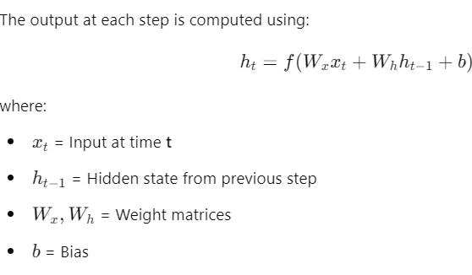  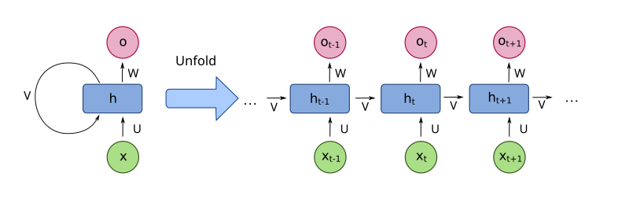  Limitations of RNNs  - Vanishing Gradient Problem: Hard to retain long-term dependencies.  - Short-Term Memory: Can only remember a few past states.  - Difficulty in Processing Long Sequences: Performance drops for longer input sequences | 10 | 5 | CO4 | 1 | 3.6.2
 | (OR)
16.b. | Explain the architecture and working of a Long Short-Term Memory (LSTM) network. Use a labeled diagram to illustrate how it overcomes the limitations of RNNs.  Solution:  - LSTM is a special type of RNN designed to handle long-term dependencies.  - It introduces memory cells and gates (input, forget, and output gates) to control information flow.  - Used in machine translation, speech-to-text, and chatbot responses.  Architecture of LSTM  - Forget Gate: Decides which past information to discard.  - Input Gate: Controls what new information should be stored.  - Cell State: Stores long-term dependencies.  - Output Gate: Determines the final output at each step.  Diagram of LSTM  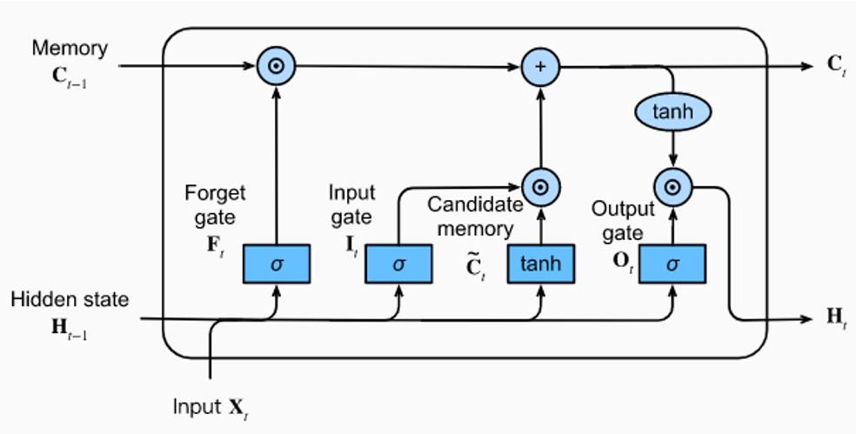  How LSTM Overcomes RNN Limitations  - RNNs are effective for short-term sequence learning but struggle with long-term dependencies.  - LSTMs improve upon RNNs by introducing gates that regulate memory retention.  - Both are widely used in natural language processing, speech recognition, and predictive analytics.  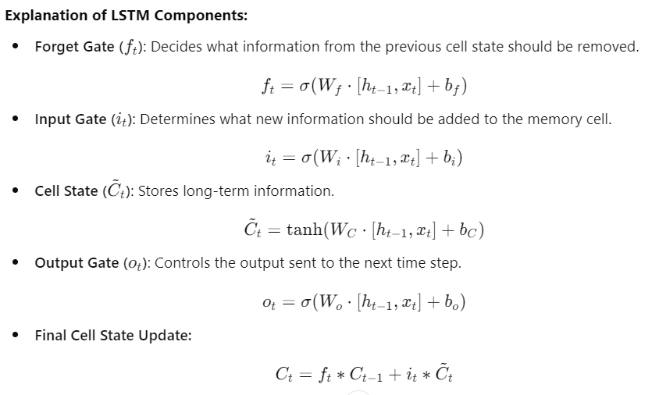  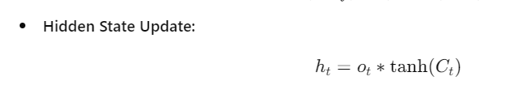 | 10 | 5 | CO4 | 3 | 3.6.2
  Feature | RNN | LSTM
  Memory Handling | Short-term memory only | Long-term memory retention
  Gradient Issues | Suffers from vanishing gradients | Uses gates to prevent vanishing gradients
  Sequence Length | Struggles with  long sequences | Efficient in processing long dependencies
  Use Cases | Simple sequential tasks | Complex NLP, translation, time-series

